High-resolution and large field-of-view Fourier ptychographic microscopy and its applications in biomedicine
  - An Pan, Chao Zuo and Baoli Yao
https://doi.org/10.1364/OE.23.003472

Introduction
Feature points:
- High Resolution
- Wide FOV
- Quantitative Phase Recovery
Why the need? Limitations of the existing technology
- Phase Loss
- Aberration induced Artifacts
- Narrow depth of field
- Trade off: Resolution and FOV
FPM is an optimization problem Euler's formula: Connection with structured illumination Microscopy (See Connection with SIM)

Problems in detail:
- Objective lens acts as a low pass filter with cut-off frequency determined by Numerical Aperture (NA); NA=n*sin(theta); acts as a resolution limit
- A better resolution (larger NA) implies a smaller FOV and a shorter DOF that makes aberration correction harder.
- Resolvable pixels, Space-Bandwidth Product (SBP)
- Scanning FOV with a high NA objective may lead to scanning, refocusing and stitching artifacts.
- Biological cells have poor absorption and contrast under conventional microscopes is low.
- Spatial structures - uneven distribution of refractive index - phase information: camera sensors record intensity and information gets lost. Requires labelling with fluorochromes which has limitations: long preparation time, phototoxicity, photobleaching, etc.
- Zernike Phase Contrast Microscopy: Non-linear relationship with its phase
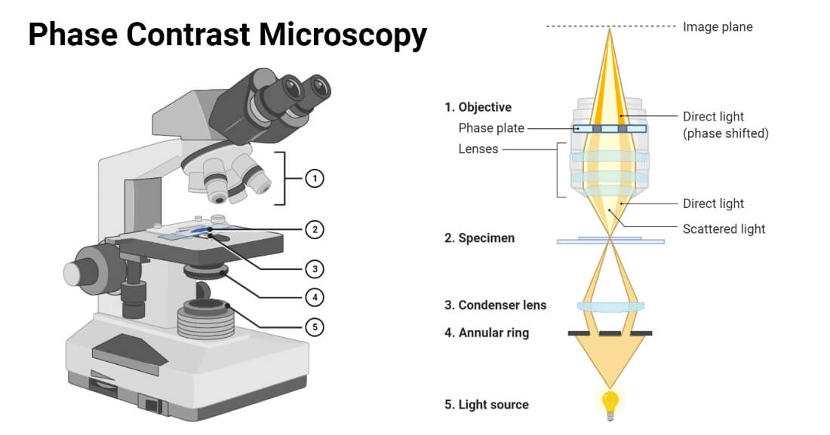
Figure 1 phase-contrast-microscopy
- Coherent Diffraction Imaging: lens less imaging system (noise sensitive)
Ptychography: acquires multiple diffraction patterns through the scan of a localized illumination. Redundant information in the overlap regions of the illuminated spots is exploited for phase retrieval.
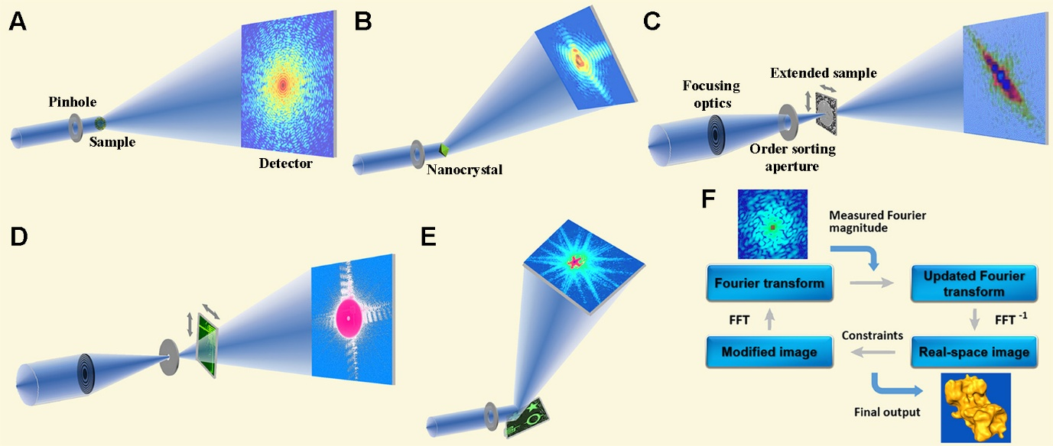
Figure 2 Schematic layout of five main CDI methods and iterative phase retrieval algorithms. (A) Plane-wave CDI: A plane wave illuminates a sample, and an oversampled diffraction pattern is measured by a detector. (B) Bragg CDI: The diffraction pattern surrounding a Bragg peak is acquired from a nanocrystal. (C) Ptychography: A coherent x-ray probe is generated by an aperture or focusing optics. An extended sample is scanned through the probe on a 2D grid, and diffraction patterns are collected from a series of partially overlapping regions. (D) Fresnel CDI: A sample is positioned in front of (or behind) the focal spot of a coherent x-ray wave, and the Fresnel diffraction pattern ismeasured by a detector. (E) Reflection CDI: A coherent x-ray wave is specularly reflected off a sample on a substrate, and the diffraction intensity around the reflected beam is collected by a detector. (F) Phase retrieval algorithms iterate back and forth between real and reciprocal space. In each iteration, various constraints, including support, positivity (i.e., electron density cannot be negative), or partially overlapping regions, are enforced in real space, while the measured Fourier magnitude is updated in reciprocal space. Usually, after hundreds to thousands of iterations, the correct phase information can be recovered. Coherent Group Website

Fourier Ptychography Microscopy
- The insight of FPM is that the objective can only collect light at certain angles, termed NA, however, parts of the scattering light can also be collected due to light matter interaction (Rayleigh or Mie scattering considering the feature size of sample).
- Instead of conventionally starting with HR and stitching together for a larger FOV, FPM uses low NA objective to take advantage of its innate large FOV and stitches together low resolution (LR) images in Fourier space to recover HR.
- There is no need for mechanical scanning and successive refocusing

Theory and Algorithm
- LED array mounted under the sample, a light microscope with a low-NA objective lens, and a monochromatic imaging sensor.
- Successive illumination from multiple angles: relative displacement between spectrum of sample and aperture of objective lens
- Low Resolution images from each angle
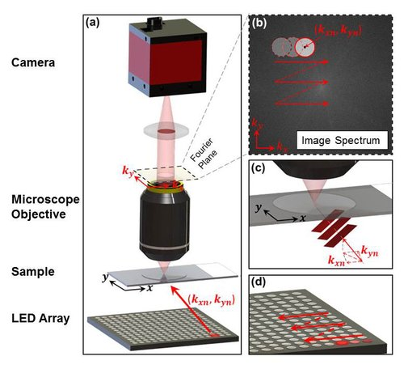
Figure 3 (a) Schematic of the FPM setup (b) The objective’s Pupil function imposes a well-defined constraint in the Fourier space. (c) Constraint is panned across the Fourier space to reflect the angular variation of angle-varied illuminations (Fourier translation theorem) (d) LED array for multi-angled illuminations Setup

Optics Theory
Assumption: Incident light is an ideal plane wave and sample is relatively thin
For each $LED_{m,n}$ (row m, column n) there’s an associated, illumination wave vector $\left(k_{x,m,n} , k_{y,m,n}\right)$
Transmitted wave field from sample is $O\left(x , y\right).e^{\left(i , k_{x,m,n}x,ik_{y,m,n}y\right)}$
$O\left(x , y\right)$ is sample's transmission function and $P\left(k_{x} , k_{y}\right)$ is Pupil Function.
Coordinate transform of pupil function in spatial domain, termed Coherent Transfer Function acts as a low pass filter of an imaging system. The Fourier transform of the object function,
$$\begin{aligned}\tilde{O}\left(k_{x},k_{y}\right)=F\left\{O\left(x,y\right)\right\}=\iint{O\left(x,y\right)}.e^{-i\left(xk_{x}+yk_{y}\right)}dxdy \end{aligned}$$ | (1)
Image sensor captures an LR intensity image $I_{m,n}$ given by
$$I_{m,n} =| {F^{-1}\left\{F\left\{ O\left(x , y\right).e^{\left(i , k_{x,m,n}x,ik_{y,m,n}y\right)}\right\}.P\left(k_{x},k_{y}\right)\right\}|}^{2}$$ | (2)
$$I_{m,n} =| F^{-1}\left\{ \tilde{O}\left(k_{x}-k_{x,m,n} ,k_{y}-k_{y,m,n} \right).P\left(k_{x},k_{y}\right)\right\}│^{2}$$ | (3)
FPM attempts to eliminate or minimize the variations in amplitude between simulation patterns and captured images iteratively: Non-convex Optimization
$$\min_{\tilde{O}\left(k_{x},k_{y}\right)}{ϵ}= \min_{\tilde{O}\left(k_{x},k_{y}\right)}{\sum_{m,n}{\sum_{x,y}{│\sqrt{I_{m,n}\left(x,y\right)} -\left|F^{-1}\left\{ \tilde{O}\left(k_{x}-k_{x,m,n} ,k_{y}-k_{y,m,n} \right).P\left(k_{x},k_{y}\right)\right\}\right|│^{2}}}}$$ | (4)

Algorithm
The algorithm to carry out the optimization problem comprises the following steps:
- An initial HR complex amplitude guess of the pupil function and sample spectrum, $P_{o}\left(k_{x} , k_{y}\right)and\overset{\sim }{O_{o}}\left(k_{x} , k_{y}\right)$ respectively. Initial guess of pupil function is a circular shape due to objective design and zero phase (nature of CTF). Up-sampled LR image is taken as first guess for sample spectrum.
- The exit wave at the Fourier plane can be estimated by multiplication
$$φ_{m,n}^{e}\left(k_{x},k_{y}\right)=\tilde{O_{o}}\left(k_{x}-k_{x,m,n} ,k_{y}-k_{y,m,n} \right).P_{o}\left(k_{x},k_{y}\right)$$ | (5)
And the simulated LR image on the image plane is inverse Fourier Transform of it:
$$φ_{m,n}^{e}\left(x,y\right)=F^{-1}\{φ_{m,n}^{e}\left(k_{x},k_{y}\right)\}$$ | (6)
It would have some amplitude and Phase information.
- The modulus of the simulated LR image is replaced by the square root of the actual measurement, and the phase remains unchanged.
$$φ_{m,n}^{u}\left(x,y\right)=\sqrt{{I^{c}}_{m,n}\left(x,y\right)} \frac{φ_{m,n}^{e}\left(x,y\right)}{|φ_{m,n}^{e}\left(x,y\right)|}$$ | (7)
- The modified LR image is then used to update the corresponding spectrum region of sample estimate in the Fourier domain.
$\tilde{O}\left(k_{x},k_{y}\right)=F\{φ_{m,n}^{u}\left(x,y\right)\}$. $P\left(k_{x},k_{y}\right)+φ_{m,n}^{e}\left(k_{x},k_{y}\right)[1-P\left(k_{x},k_{y}\right)]$ | (8)
Single iteration is completed when all the captured images are used to update corresponding parts of the sample spectrum in Fourier domain. $i$ iterations are repeated until the solution converges in the limits of an error metric defined by
$$∈_{i}=\frac{\sum_{x,y,m,n}{{\left(\sqrt{{I^{c}}_{m,n}\left(x,y\right)}-\left|φ_{i,m,n}^{e}\left(x,y\right)\right|\right)}^{2}}}{\sum_{x,y,m,n}{{I^{c}}_{m,n}\left(x,y\right)}}$$ | (9)
The modification in the LR image does not update the pupil or object function in the beginning. There are multiple frameworks to update these functions that can be implemented.

Updating Algorithms
[1]

Connecting techniques

Connection with Ptychography
Ptychography which works by capturing multiple diffraction patterns through the scan of a localized illumination on an extended object.
- Redundant information in the overlap regions of the illuminated spots is exploited for phase retrieval. Adjacent illuminated spots from the sample have overlapping regions in the diffracted pattern and forms a coherent superposition essentially storing the phase relationships of the sample at those spots (positions). These patterns are inverted to extract the complex sample profile.
- For phase retrieval algorithms, the object support constraint (finite support condition: function’s domain has a limited number of points that yield non-zero values) are given by the confined illumination beam in spatial domain and the reciprocal constraint (amplitude constraint) is the diffraction pattern in Fourier domain.
- In FPM, the object support constraint is the confined pupil function in the Fourier domain (low-pass filter) and the reciprocal constraints are the low-resolution images in spatial domain. Both, ptychography and FPM requires more than 30% overlap for a precise phase recovery.
In fact, the LR images of FPM are equivalent to the 90◦ rotation of ptychographic diffraction patterns in the phase space of 4D Wigner distribution function, which means that a linear transformation mathematically links these two datasets.

Connection with SIM
Structured Illumination Microscopy (SIM) and FPM are connected through Euler’s Formula. The illumination wavefront in SIM is the cosine structured illumination and through Euler’s Formula, it is equivalent to covering the Fourier space with three different angle illuminations (two symmetrical light beams and a normal light beam)
$$1 + e^{-iθ} + e^{iθ }= 1+ 2cos{θ}$$ | (10)

